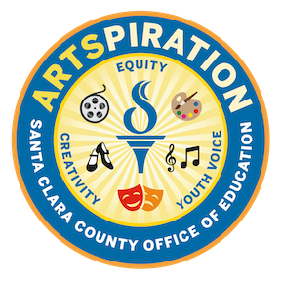
Young Artist Showcase Submission Worksheet
Name: ________________________________
Grade: ________________________________
Teacher: _______________________________

What is the name/title of your artwork?
What materials did you use?
How was your voice represented in your art? What inspired this piece?
Did your artwork change from your original idea to the finished piece?
What are you most proud of when you look at your art?

This worksheet is to brainstorm your ideas before turning in the artwork online. Ask your teacher or parent for help, if needed.

